Describing graphs, charts, tables

General information.

- Types of image information.

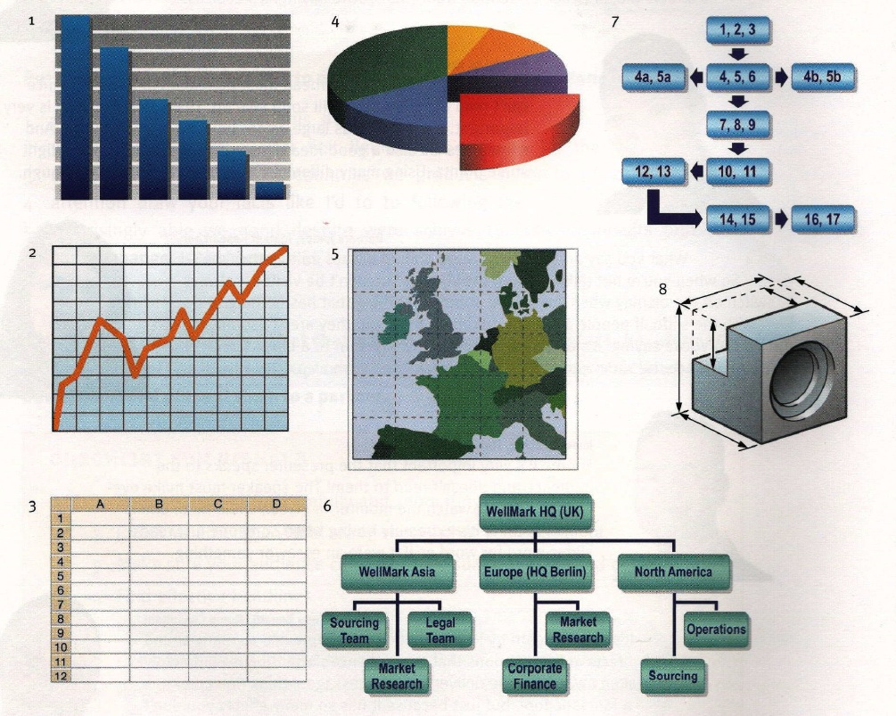
- A bar chart
- A graph
- A table
- A pie-chart
- A map
- A multiple diagram
- A process or cycle (flow-chart)
- An illustration

2. The rules to follow while describing.
One of the most important things to do is to get the main idea of the graph/chart/table. First, identify the main features of the image information. What is happening? What are the biggest numbers? If it is a time or comparison graph, what are the biggest changes? What are the trends?
- In time graphs you have to describe changes over time.
- In comparison graphs you have to compare different items - countries, people, products, places, etc.
The vocabulary for each kind of graph is different: * здесь даем ссылку на словарь
- In time graphs you use time vocabulary to describe change: rose. fell, declined, shot up, increased, remained steady, etc.
- In comparison graphs you compare: twice as much as, more than, less than, the same amount, both X and Y have the same figure, etc.
- Sometimes there is just too much information in a graph. You may need to group information. Grouping information means putting two or three similar or related things together.
Ideally you need to find one main idea and, if possible, one or two smaller ideas.
- Don't mention the small or unimportant things.
- Don’t repeat the same words, use synonyms.
- Pick an idea and find information that supports it.
The description should consist of:
Introduction: say/write what a graph/chart/table represent (E.g.: The graph shows the fluctuation in the number of people at a London underground station over the course of a day.)
The main body: describe the trends.
Trend 1: …..
Trend 2: …..
Conclusion.

